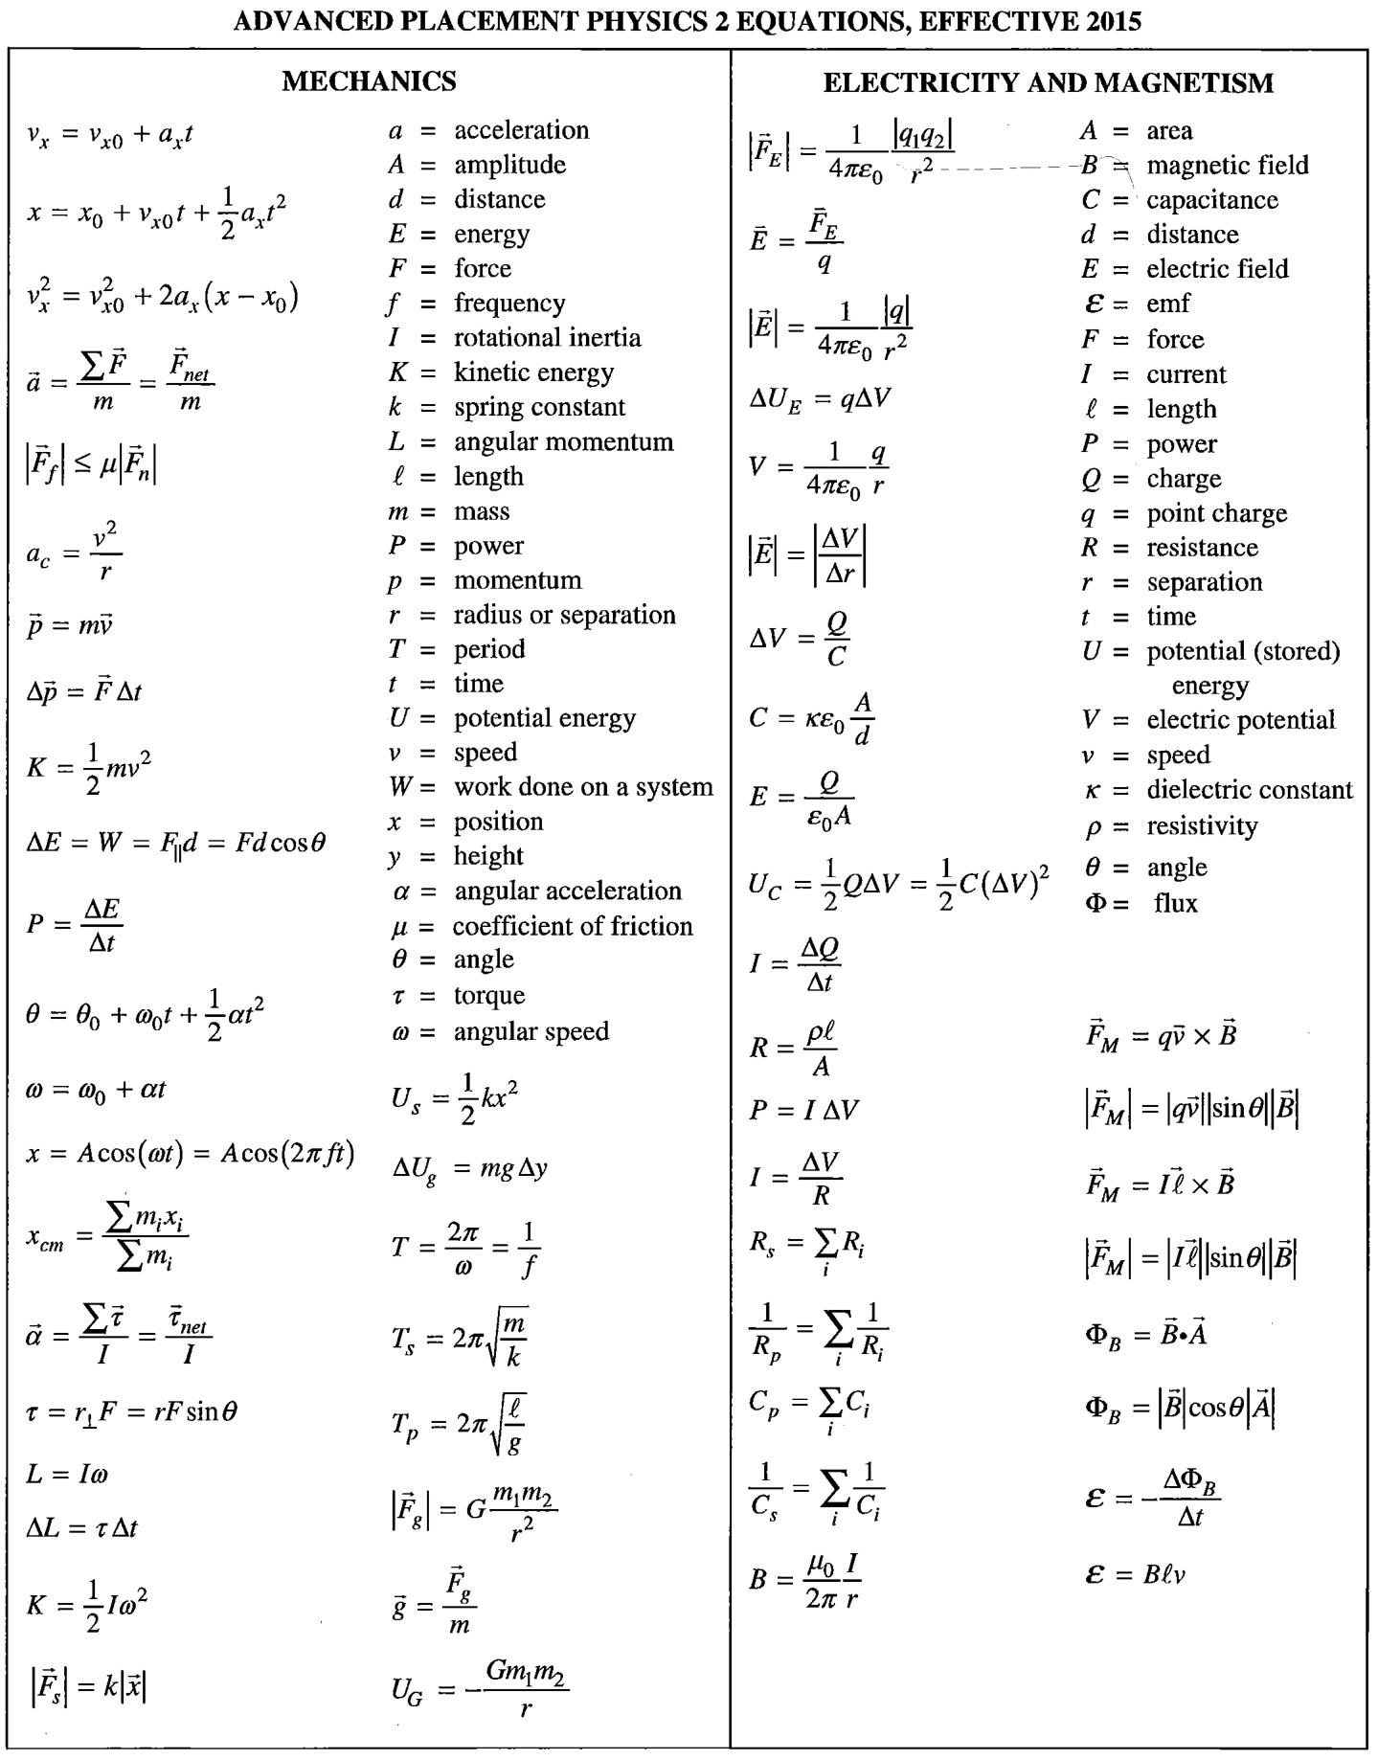

⧫ = time constant

Vc =  (1 – e – t/)  = RC

Vc = Voe – t/