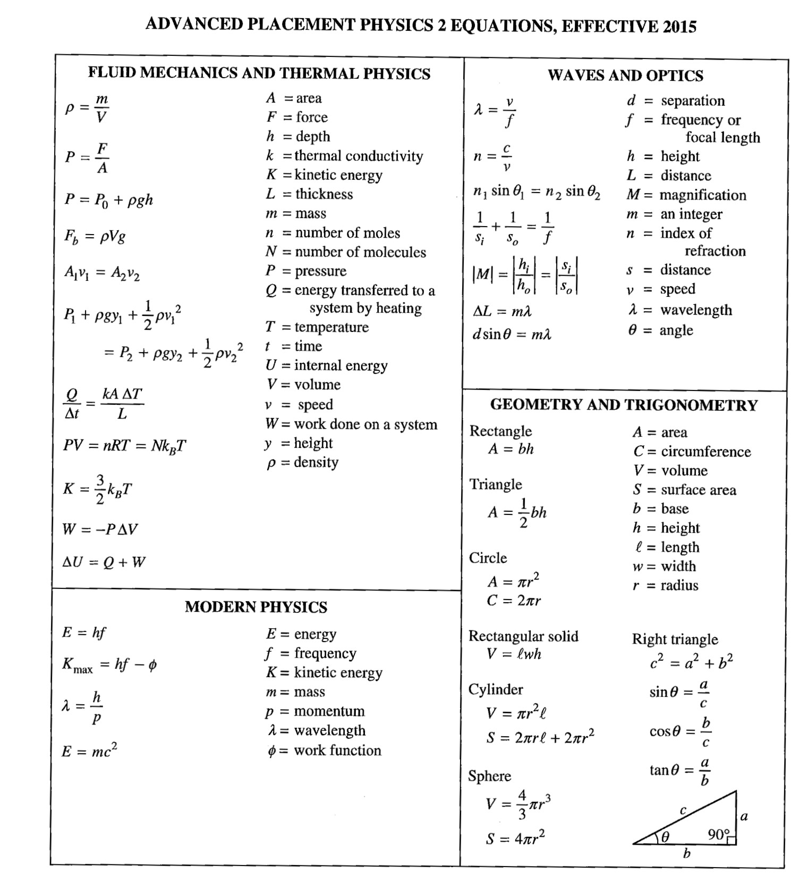

l = length

 = coefficient of thermal expansion

c = specific heat capacity

Lv,f = latent heat

S = entropy

l =  lo T S = Q / T

Q = mcT eff = 1 – TL / TH

Q = mLv,f

E = – 13.6 (1/nf2 – 1/no2)

n = principal quantum number