Page 218 Solenoids

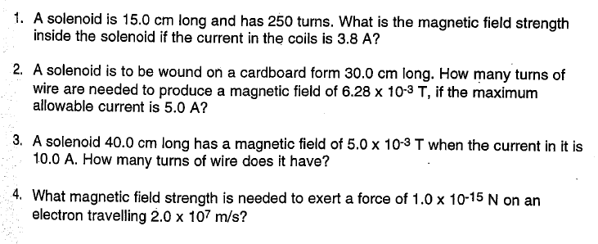
4b) What is the magnitude of acceleration of the electron in the question above?

Ans. 1) 8.0 x 10 ^{– 3} T 2) 300 turns 3) 159 turns 4) 3.1 x 10 – T 4b) 3.43 x 10 25 m/s²

